PRACTICAL 2: Run basic Commands of Git
- Initialize Repository
- Clone Repository
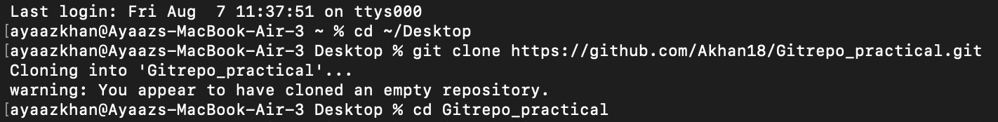
- Check status
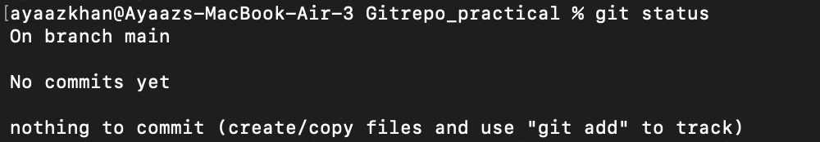

- Add files to Staging Area
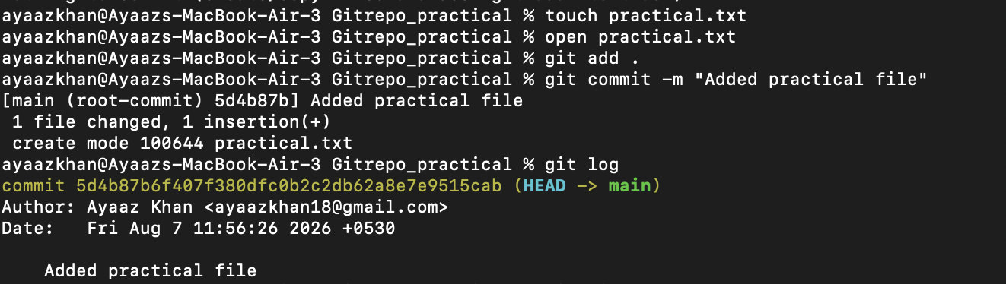
- Commit changes


- View commit history
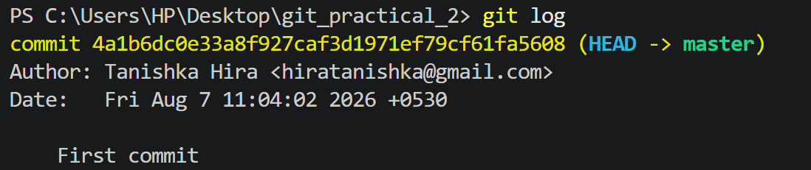
- View differences

- Connect Remote Repository
- Push changes

- Pull changes